USER GUIDE

Table of Contents

# Introduction

This is a Web-based Application for keeping track of all your upcoming and previously completed events that the CSEA conducts.

# Login Page

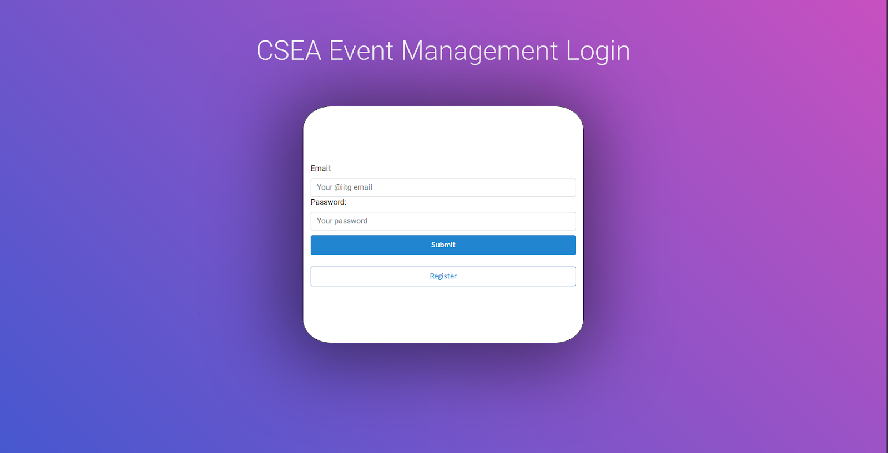

This is your typical login page. Here you enter your Outlook Email address and your Password. Clicking on Submit will take you to your homepage.

However, if your credentials are incorrect, you’ll be prompted to re-enter them.

If you haven’t registered yet, you’ll be able to register by clicking on the Register button, doing which will take you to a registration page.

# Registration Page

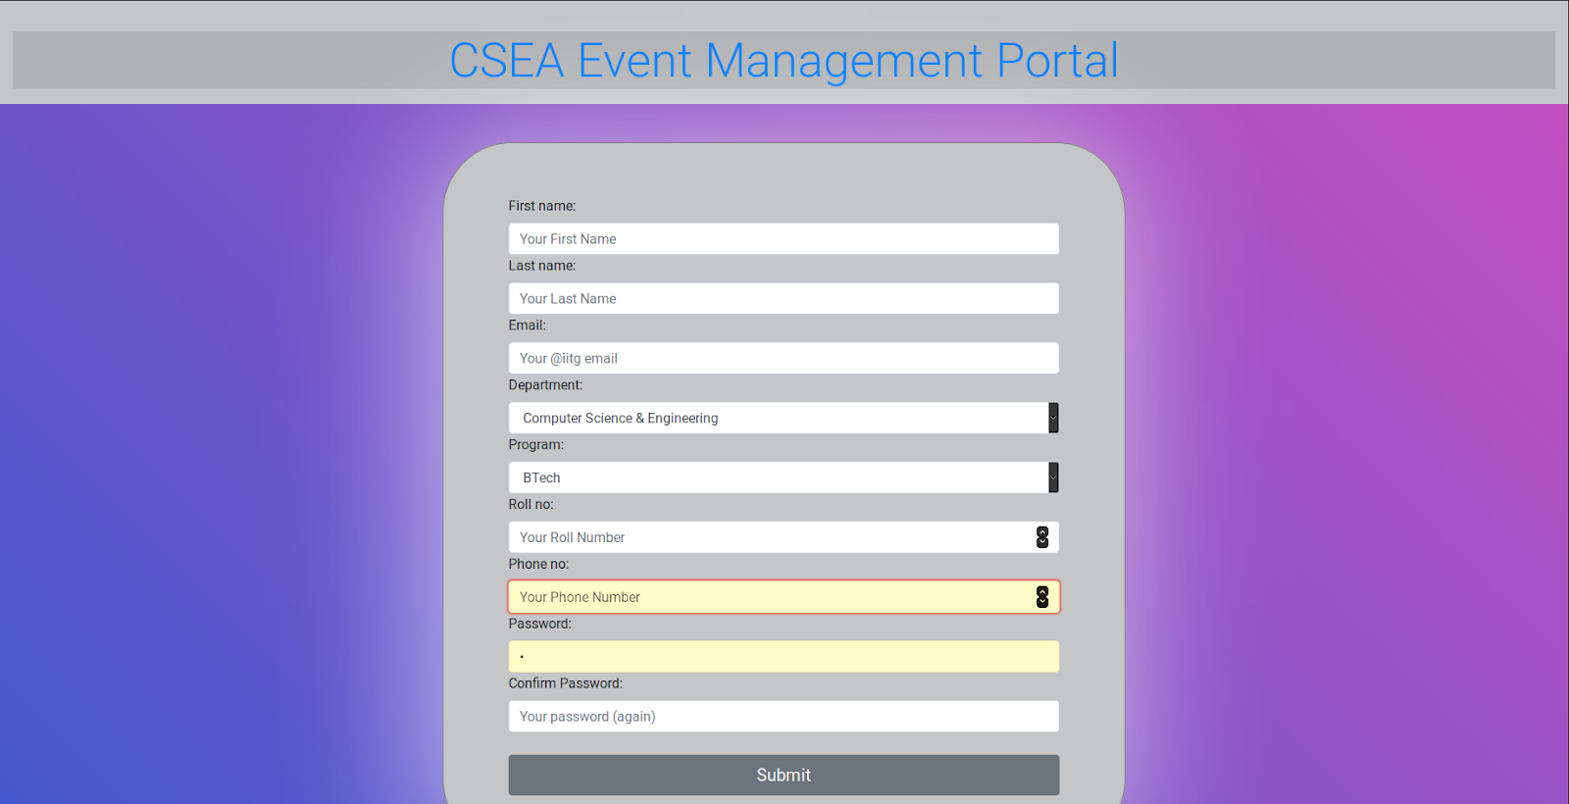

This is the registration page for users who’re not yet registered users. On this page, you enter your details as per the instructions provided in the form. After entering your name, email, course and your contact number, you choose a password. We suggest you use a password with at least 8 characters, which include both lowercase and uppercase alphabets, a numerical character and a special character.